Report For Assignment 4

**Trial 1 with 10 integers:**

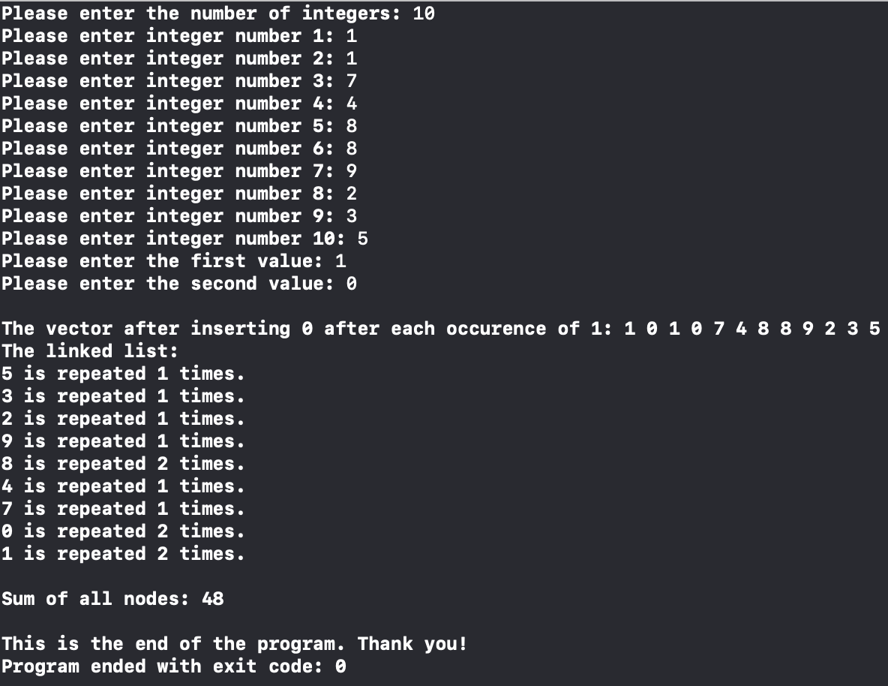

**Trial 2 with 5 integers:**

